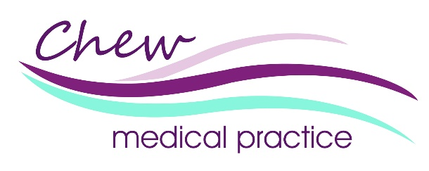

Prospective Employees Privacy Notice

We are Chew Medical Practice, a well-established GP Practice. Our General Practitioners and allied healthcare professionals provide primary medical care services to our practice population and are supported by our administrative and managerial team in providing care for patients.
This privacy notice explains how we as a data controller use any personal data we collect about you as a prospective employee of Chew Medical Practice.

How do we collect your personal data?
We may collect your personal data in a number of ways, for example:
- When you register with our recruitment website
- When you apply for a vacancy and submit an application form
- When we receive your personal data from third parties, for example security screening and recruitment agencies

What types of personal data do we collect about you?
We may collect the following types of personal data:
- Your name, job title, address, email address, telephone number and other contact information
- NI number and date of birth
- Details of any current health conditions and prescribed medications
- Right to work documentation and other security screening information
- Equality and diversity information

How will we use the personal data we collect about you?
We may use your personal data in the following ways:
- To facilitate the recruitment process
- To comply with legal obligations
Any medical or health related personal data will be treated with confidence in line with the Common Law Duty of Confidence.

Call recording
All calls made from and received by Chew Medical Practice are recorded and may be used to support the learning and development of our staff.
Call recordings are managed in the same way as all other personal data processed by us and in line with current legislation.

Data processors
We may use the services of a data processor to assist us with some of our data processing, but this is done under a contract with direct instruction from us that controls how they will handle prospective employee information and ensures they treat any information in line with the General Data Protection Regulation, confidentiality, privacy law, and any other laws that apply.]

How will we share your personal information?
We will not share your information with third parties without your consent unless the law allows or requires us to.

How long do we keep your personal data
We will hold your personal data for 1 year after you apply for a role at Chew Medical Practice. If you are successful in applying for a role at Chew Medical Practice, then your application will form part of your employee record which will be held for 6 years after you leave Chew Medical Practice.

Legal Basis
The legal basis for us to process your personal data is based on our legitimate interest in processing your personal information because it is necessary in order for us to process your application for the role you have applied for.
We will use your sensitive personal information, such as that relating to your race, ethnic origin, and health for the purposes of the performance or exercise of our or your rights and obligations under employment law.
In some circumstances, we may process your personal information on the basis that we are required to do so in order to comply with legal obligations to which we are subject.
Your rights
You have a right to:
- access the information we hold about you;
- correct inaccuracies in the information we hold about you;
- withdraw any consent you have given to the use of your information;
- complain to the relevant supervisory authority in any jurisdiction about our use of your information; and
- in some circumstances:
  - ask us to erase information we hold about you;
  - request a copy of your personal data in an electronic format and require us to provide this information to a third party;
  - ask us to restrict the use of information we hold about you; and
  - object to the use of information we hold about you.
You can exercise these rights by contacting us as detailed below.

Data Protection Officer
Our Data Protection Officer (DPO) function is provided by the HealthHero Integrated Care Data Protection Officer service.

How to contact us
If you have any questions about our privacy notice, the personal information we hold about you, or our use of your personal information then please contact our Data Protection Team at:
Data Protection Team
Data Protection Team
Chew Medical Practice
Chew Lane
Chew Stoke
Bristol
BS40 8UE

Or

BSWICB.secretarychew@nhs.net
All data protection queries will be initially dealt with by the practice data protection team and escalated to the HealthHero Integrated Care Data Protection Officer service if required.

How to make a complaint
You also have the right to raise any concerns about how your personal data is being processed by us with the Information Commissioners Office (ICO):
https://ico.org.uk/concerns
0303 123 1113

Changes to our privacy notice
We keep our privacy notice under regular review and we will place any updates on this webpage. This privacy notice was last updated on Monday 23rd June 2025.

